* video for the chapter 5

# 2 required and 2 selected

# Example : State space model of an electric circuit

# Systems Analysis - Electrical Circuit to State Space

# <https://www.youtube.com/watch?v=_9Ew2LXPsWI>

# <https://www.youtube.com/watch?v=uIeFqmSB_K0>

# start from 7:30

# <https://www.youtube.com/watch?v=sL0LtyfNYkM>

# <https://www.youtube.com/watch?v=eDikPzY9Tzo&t=392s>

<https://www.youtube.com/watch?v=BmjVTQIloAY>

<https://www.youtube.com/watch?v=gAlF55qxZBc>

* video for the chapter 6
* <https://www.youtube.com/watch?v=AFvrEUtVp38>

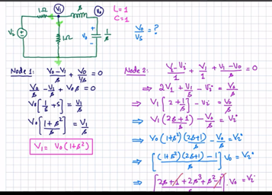

* Application of the previous lecture for the application in op circuit design

<https://www.youtube.com/watch?v=090Djhigirg>